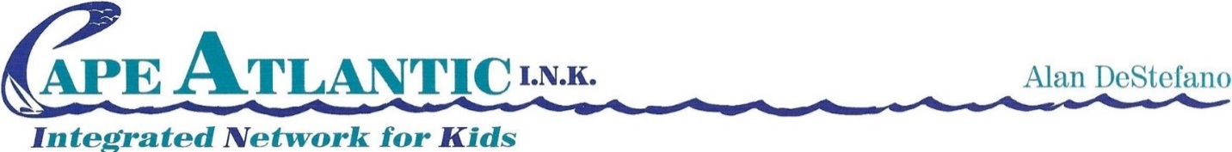
Executive Director

Authorization Form for Electronic Messaging and Video Conferencing
I authorize Cape Atlantic I.N.K. to use the following methods to communicate with me: (Please check and complete for all that apply.)

☐ Email: Click or tap here to enter text.
☐ Text (Data Rates May Apply): Click or tap here to enter text.
☐ Voicemail Messages: Click or tap here to enter text.
☐ Video Conferencing (Without Recording)

I authorize Cape Atlantic I.N.K. to use the above Electronic Messaging/Video with:

☐ Youth/Parent/Guardian only
☐ Youth/Parent/Guardian and Child Family Team (CFT) Members

I understand that electronic messaging does not substitute for verbal and direct communication.
I understand that electronic messaging may not be completely private.
I understand text messaging can be a risk if a phone is lost, stolen, or compromised.
I understand the above risks also pertain to all CFT members that I authorized above.
I understand that I can revoke this authorization at any time.

AUTHORIZATION

☐ I do authorize Cape Atlantic I.N.K. to use the above Electronic Messaging or Video Conferencing to communicate with me.

☐ I do NOT authorize Cape Atlantic I.N.K. to use the above Electronic Messaging or Video Conferencing to communicate with me.

Click or tap here to enter text. _______________________________ Enter Date
(Parent/Guardian Name) (Signature Parent/Guardian Name) Date

Click or tap here to enter text. ______________________________ Enter Date
(Youth 14 years old and over) (Signature Youth 14 years old and over) Date

Youth Id# Click or tap here to enter text.

